1. Problem Analysis and Domain Understanding
Domain: Clinical symptom-based preliminary diagnosis support.
Objective: Given a patient's reported symptoms, the system must infer a possible condition (flu, viral infection) and recommend an action (rest), using logical facts and rules rather than statistical/ML methods.

Entities
Patient — Ravi

Observable symptoms (given facts)
- Ravi has fever
- Ravi has cough
- Ravi has body pain

Domain constraints
- Fever + cough together suggest flu
- Flu + body pain together suggest viral infection
- A confirmed viral infection warrants a rest recommendation

Expected inference
The system should conclude that Ravi has a viral infection and should be advised to rest, and should be able to justify this conclusion by tracing the chain of rules that were fired.

2. Knowledge Engineering and Knowledge Base Design
Knowledge engineering steps followed:
1. Identify domain entities: Patient (Ravi).
2. Identify predicates needed to describe symptoms and conditions: Fever, Cough, BodyPain, Flu, ViralInfection, NeedsRest.
3. Acquire domain rules from the medical expert statements given in the problem.
4. Encode facts and rules in both Propositional Logic (for quick boolean reasoning) and First-Order Logic (for generality across patients).
5. Choose an inference strategy: forward chaining for data-driven diagnosis, backward chaining for goal-driven verification (e.g. "does Ravi need rest?"), and resolution for formal proof.

Knowledge Base contents
Facts (3):
Fever(Ravi)
Cough(Ravi)
BodyPain(Ravi)
Rules (3):
R1: ∀x (Fever(x) ∧ Cough(x) → Flu(x))
R2: ∀x (Flu(x) ∧ BodyPain(x) → ViralInfection(x))
R3: ∀x (ViralInfection(x) → NeedsRest(x))

3. Propositional Logic Representation
Propositional symbols:
Symbol | Meaning
P | Ravi has fever
Q | Ravi has cough
R | Ravi has body pain
S | Ravi has flu
T | Ravi has viral infection
U | Ravi should rest

Facts:
P, Q, R (all true)
Rules:
P ∧ Q → S (fever and cough imply flu)
S ∧ R → T (flu and body pain imply viral infection)
T → U (viral infection implies rest is advised)
Limitation: propositional logic needs a separate symbol set for every new patient (e.g. P', Q' for a second patient), so it does not scale — this motivates the FOL representation below.

4. First-Order Logic Representation
Predicates:
Predicate | Meaning
Fever(x) | x has fever
Cough(x) | x has cough
BodyPain(x) | x has body pain
Flu(x) | x has flu
ViralInfection(x) | x has a viral infection
NeedsRest(x) | x should be advised to rest

Constant: Ravi. Variable: x.
Facts:
Fever(Ravi)
Cough(Ravi)
BodyPain(Ravi)
Rules (universally quantified Horn clauses):
R1: ∀x (Fever(x) ∧ Cough(x) → Flu(x))
R2: ∀x (Flu(x) ∧ BodyPain(x) → ViralInfection(x))
R3: ∀x (ViralInfection(x) → NeedsRest(x))
This representation generalises to any patient by simply asserting new facts (e.g. Fever(Meena)) — the same three rules apply without modification.

5. Unification and Resolution

5.1 Unification (at least two predicates)
Unification finds a substitution θ that makes two literals syntactically identical (Most General Unifier, MGU).
Literal 1 | Literal 2 | MGU θ | Result
Fever(x) | Fever(Ravi) | {x / Ravi} | Fever(Ravi)
Flu(x) ∧ BodyPain(x) | Flu(Ravi) ∧ BodyPain(Ravi) | {x / Ravi} | Flu(Ravi) ∧ BodyPain(Ravi)

Unification is what lets the general rule R1 (which talks about a variable x) be applied to the specific fact about Ravi: substituting x/Ravi turns the rule's antecedent Fever(x) ∧ Cough(x) into the concrete query Fever(Ravi) ∧ Cough(Ravi), which matches the known facts.

5.2 Resolution (proving NeedsRest(Ravi))
Convert rules to clausal (CNF) form (A → B ≡ ¬A ∨ B):
C1: ¬Fever(x) ∨ ¬Cough(x) ∨ Flu(x)
C2: ¬Flu(x) ∨ ¬BodyPain(x) ∨ ViralInfection(x)
C3: ¬ViralInfection(x) ∨ NeedsRest(x)
C4: Fever(Ravi) C5: Cough(Ravi) C6: BodyPain(Ravi)
Goal (negated for refutation): ¬NeedsRest(Ravi)
Resolution steps:
1. Resolve C3 {x/Ravi} with ¬NeedsRest(Ravi) → ¬ViralInfection(Ravi)
2. Resolve C2 {x/Ravi} with ¬ViralInfection(Ravi) → ¬Flu(Ravi) ∨ ¬BodyPain(Ravi)
3. Resolve with C6 (BodyPain(Ravi)) → ¬Flu(Ravi)
4. Resolve C1 {x/Ravi} with ¬Flu(Ravi) → ¬Fever(Ravi) ∨ ¬Cough(Ravi)
5. Resolve with C4 (Fever(Ravi)) → ¬Cough(Ravi)
6. Resolve with C5 (Cough(Ravi)) → ∅ (empty clause — contradiction)
Since assuming ¬NeedsRest(Ravi) leads to a contradiction (the empty clause), NeedsRest(Ravi) is proved true by refutation.

6. Forward and Backward Chaining

6.1 Forward chaining (data-driven — determine Ravi's condition)
Step | Known facts | Rule fired | New fact derived
1 | Fever(Ravi), Cough(Ravi) | R1 | Flu(Ravi)
2 | Flu(Ravi), BodyPain(Ravi) | R2 | ViralInfection(Ravi)
3 | ViralInfection(Ravi) | R3 | NeedsRest(Ravi)

Result: forward chaining terminates with Flu(Ravi), ViralInfection(Ravi) and NeedsRest(Ravi) all in the knowledge base — Ravi's condition is diagnosed as viral infection.

6.2 Backward chaining (goal-driven — prove NeedsRest(Ravi))
Goal: NeedsRest(Ravi)
- NeedsRest(Ravi) ← needs ViralInfection(Ravi) (via R3)
- ViralInfection(Ravi) ← needs Flu(Ravi) ∧ BodyPain(Ravi) (via R2)
- BodyPain(Ravi) — already a known fact ✓
- Flu(Ravi) ← needs Fever(Ravi) ∧ Cough(Ravi) (via R1)
- Fever(Ravi) — known fact ✓; Cough(Ravi) — known fact ✓
- ⇒ Flu(Ravi) proved ⇒ ViralInfection(Ravi) proved ⇒ NeedsRest(Ravi) proved
Conclusion: the goal NeedsRest(Ravi) is successfully proved by decomposing it into sub-goals that are matched against known facts.

7. Inference and Reasoning Accuracy
Both forward chaining and resolution independently confirm NeedsRest(Ravi), and backward chaining confirms it can be derived on demand — the three methods agree, which validates the correctness of the knowledge base.
Final inference chain:
Fever(Ravi) ∧ Cough(Ravi) ⇒ Flu(Ravi)
Flu(Ravi) ∧ BodyPain(Ravi) ⇒ ViralInfection(Ravi)
ViralInfection(Ravi) ⇒ NeedsRest(Ravi)
Diagnosis: Ravi has a viral infection and should be advised to rest.

8. System Architecture / Representation Diagram
The diagram below shows how a symptom input flows through the knowledge base and inference engine to a final, explainable diagnosis.
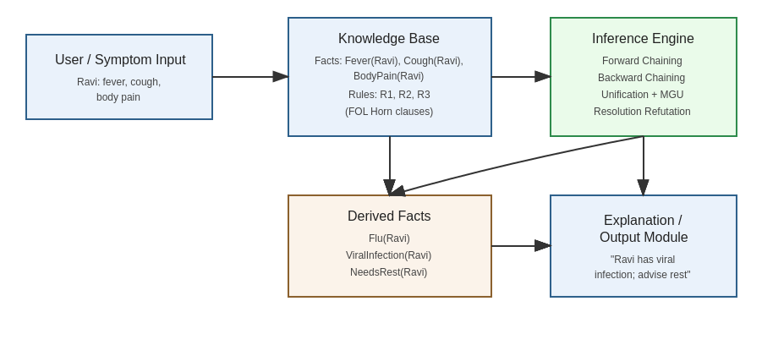

9. Prototype Implementation (Pseudocode)
A minimal forward-chaining prototype for this knowledge base:
facts = {Fever(Ravi), Cough(Ravi), BodyPain(Ravi)}
rules = [R1, R2, R3]
repeat:
for rule in rules:
if rule.antecedents ⊆ facts and rule.consequent ∉ facts:
facts.add(rule.consequent)
until no new facts are added
# Result: facts = {Fever(Ravi), Cough(Ravi), BodyPain(Ravi),
# Flu(Ravi), ViralInfection(Ravi), NeedsRest(Ravi)}
Output: “Ravi is diagnosed with a viral infection and is advised to rest.”

10. Implementation & Results
Code:
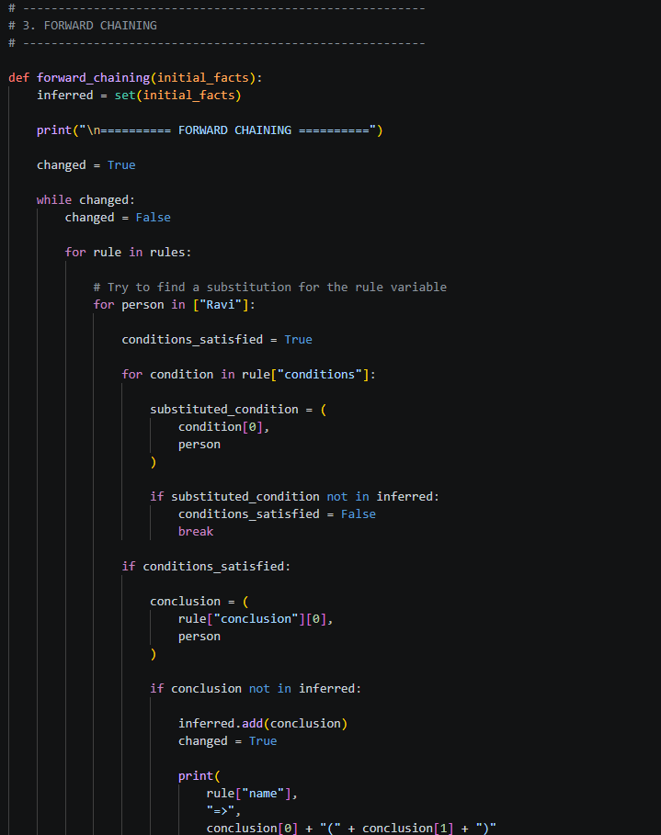
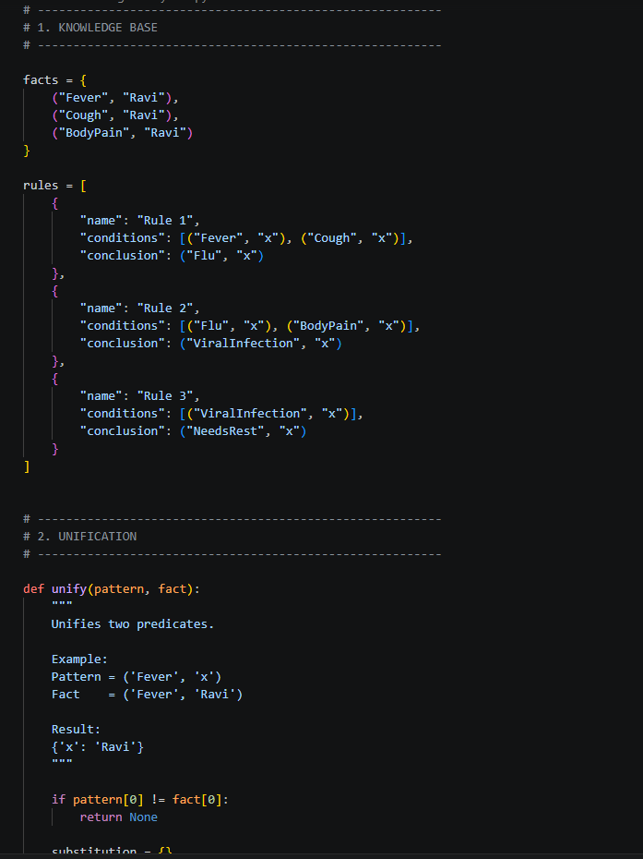

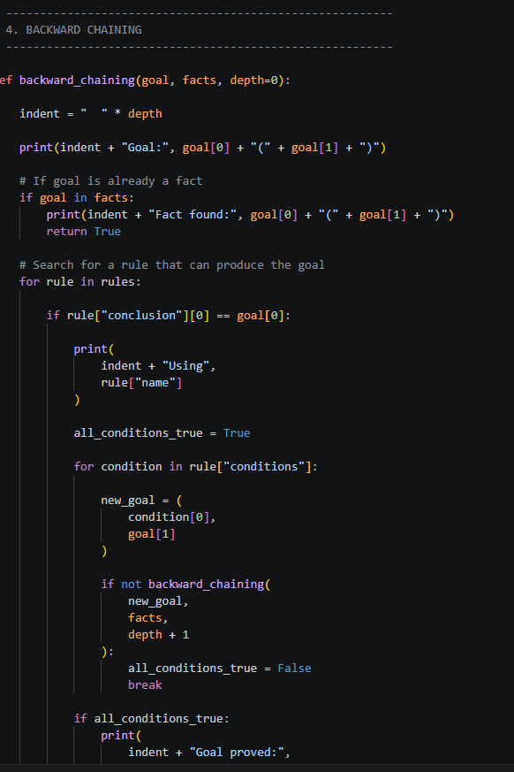

Result:

